ASSIGNMENT

ON

Artificial Intelligence

**Agent:**

In Artificial Intelligence, Agent is a self dependent entity which connected to sensors and plays an important role using

actuators and directly connected to achive goals.

**Agent Function:**

The agent function is a mathematical term which is implicated to the sequentially accessed to the action.

The function is implemented the agent program through the sensors.

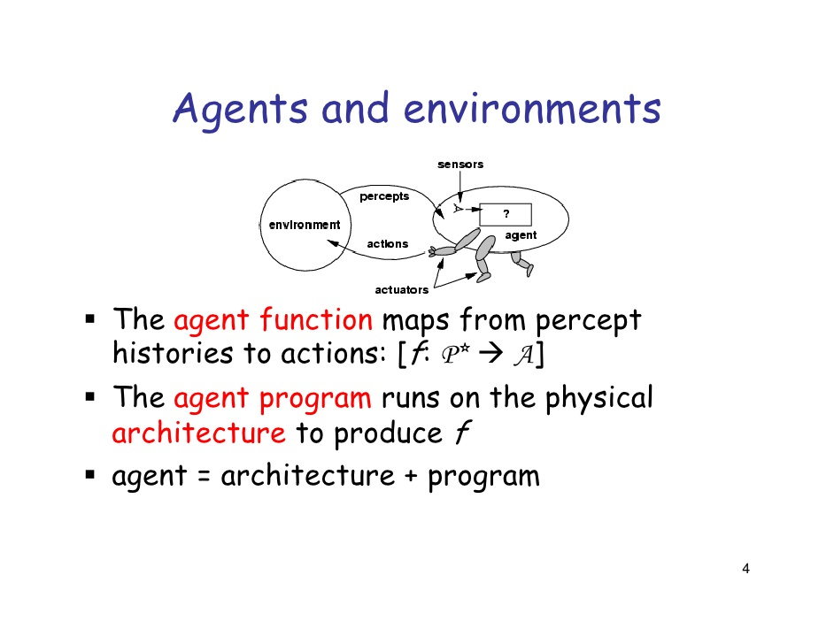

**Agent Program:**

T he agent program is a concrete implementation which is taking action in physical system. This is an autonomous entity which observes a sensor acts upon an environment to manipulate the system and information.

**Autonomy:**

Autonomy is the referred to autonomous agent where the intelligent agent is operated on its owner behalf without any interference. Non biological examples:

Autonomous robot, intelligent agent .

**Reflex Agent:**

A reflex agent is the most basic action of intelligent agent. It perform action based situation under the simplicity of the current situation. It would be like a home thermostat recognizing that the temperature arises 75 degree that the thermostat prompted to kick on. It doesn’t need to know what happened the temperature was yesterday and don’t know tomorrow.

**Model based agent:**

A model based reflex agent is one that uses it’s percept history and it’s internal memory about an internal model.

For example, the model based uses GPS to track the location and search the current location. when the brake lights of the car ahed of us on , the driver has hit the brakes so the car is slowing down in front of us

This the example of model based agent.

**Goal based agent:**

A goal based agent is the operation of operating system that based on a goal and targets that how fast it is reached goal of the minimum function agents. It is such a types of agenda which is the capable of thinking beyond the present moment to decide the best actions in order to achieve its goal.

**Utility based agent:**

A utility based agent is an agent which is based not only goal but also acts upon on the best way to reach goal Simply a goal based agents plays how it reaches goal stage but utility based agent thinks how the best way to reach goal.

**Learning agents:**

The learning agent is a tool that is capable of learning from its experiences. It starts with some basic knowledge and able to adapt  .